Exercise 1:

Implement the factory pattern using Java application (use Swing to draw the real shapes) ?

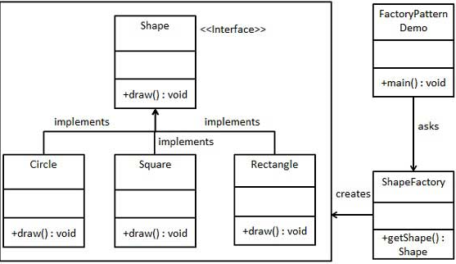

Exercise 2:

Create a Singleton Class which is not thread safe . Create two or more derived classes which extends from Thread class inside these derived classes create the instances of singleton class. Check whether only one instance of the singleton class is created or not ? Make the singleton class thread safe and repeat the exercise?

Exercise 3:

Find the prime numbers between 1000 to 5000 :

Thread 1: will find prime numbers between 1000 to 2000

Thread 2: will find prime numbers between 2000 to 3000

Thread 3: will find prime numbers between 3000 to 4000

Thread 4: will find prime numbers between 4000 to 5000

Print it in ascending and descending order?